Square Logic

SquareLogic is similar to number-based logic games such as Sudoku.

### GOAL

Your goal is to solve the puzzle by filling each square in the board with a number.

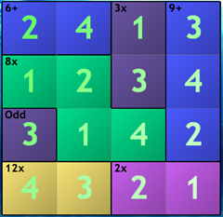

### Rules

1. No number can appear twice in the same row or column.
2. Each board is divided into differently-colored "cages".
3. Each cage shows a "rule" in the top-left corner (such as **9+**, **12x**, or **Odd**).
4. The answers for the squares in each cage must satisfy the rule. *For example:*

* A rule of **9+** means the squares in that cage must add up to 9.
* A rule of **2÷** means the two squares must divide evenly (in any order) to equal 2.
* A rule of **3=** means that is a single-square cage whose value must be 3.
* A rule of **Even** means that all squares in this cage must have odd values (2, 4, 6, or 8).
* A rule of **Straight** means that all squares in this cage must form a "straight" (like poker), IN ANY ORDER (for example: 4, 3, 5).
* A rule of **<,>** (or the "comparison" rule) means that all squares in this cage show greater-than/less-than signs to indicate their size relative to each other.
* **Note** that all cage rules - especially Subtraction, Division, and Straight - can function in any order.

### Basic controls

* **Left-click** on a candidate (at the bottom of each square) to set that value in the square
* **Right-click** on a candidate to mark it as being IMPOSSIBLE; with larger and more difficult boards, this is the most important move you make.
* **Click the "X"** in the upper-right corner of a square to clear its value.
* Use the **Solving Tip** button within the game if you get stuck or confused on any puzzle.

### Special Types of Puzzles

Some puzzles are Double Board puzzles; for these puzzles, both boards have the same answers, and you solve them both simultaneously.

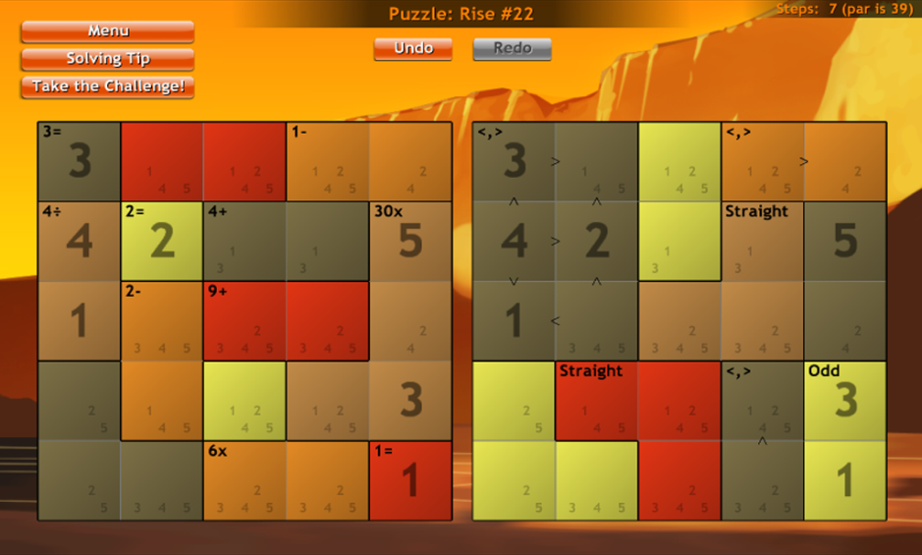

Other puzzles have **Hidden Cages**; you have to discern where the cages must go and paint in their colors as you solve the puzzle.

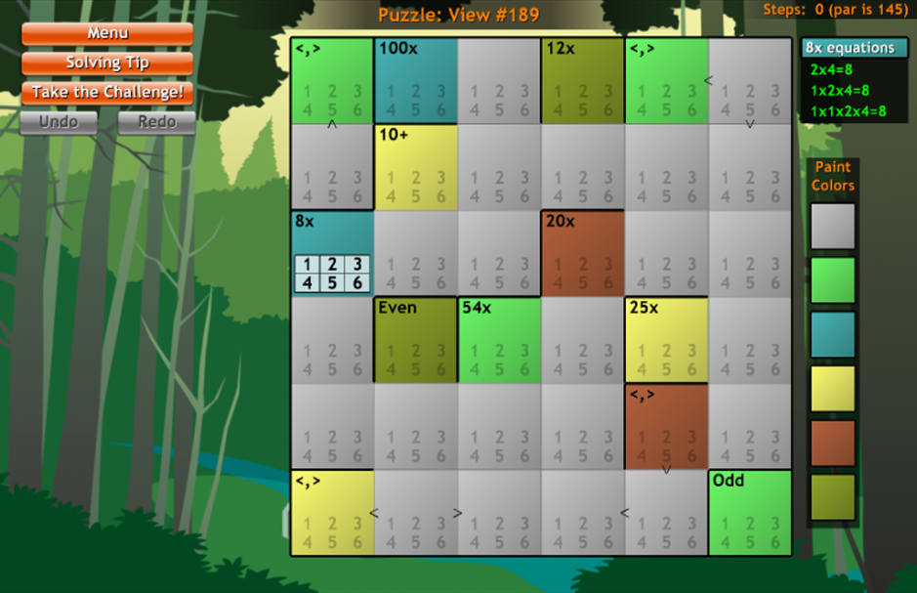

### Features

* Over 20,000 unique puzzles
* 18 different styles of puzzles; 6 different puzzle sizes, from 4x4 up to and including 9x9
* Each puzzle guaranteed to be solvable with only one possible solution without guessing
* 24 different Achievements for accomplishing goals within the game
* A hint system that gives you hints without telling you the answer right away
* Allows you to stop in the middle of any puzzle and resume later where you left off
* Solving Tips never tell you the answer; they give you suggestions on which areas of the puzzle to consider, and will get more specific each time you press the button.