Social Studies Textbooks / Primary Course Resource
Grade / Course | Image / Visual | Title / Name | Publisher | Digital Platform | Digital Access
6 | 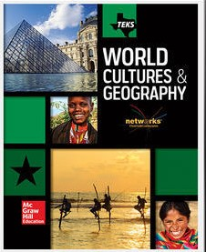 | World Cultures and Geography | McGraw Hill | PISD ConnectEd | Via Webdesk
7 |  | Texas History | McGraw Hill | PISD ConnectEd | Via Webdesk
8 |  | United States History,  Early Colonial Period through Reconstruction | HMH | PISD MyHRW | Via Webdesk
WG  Honors WG |  | World Geography | McGraw Hill | PISD ConnectEd | Via Webdesk
WH  Honors WH | 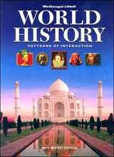 | World History, Patterns and Interactions | HMH | PISD MyHRW | Via Webdesk
US |  | (Web Based Textbook) | Discovery Ed | PISD Discovery | Via Webdesk
GOV | 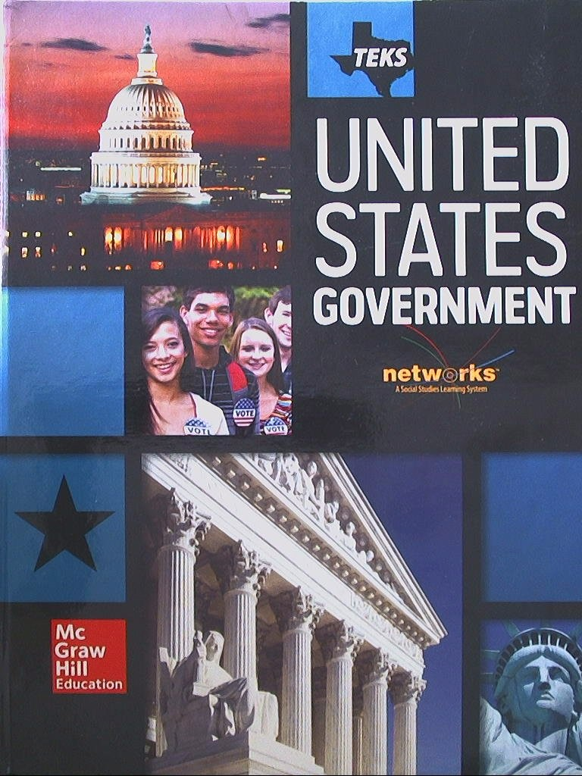 | United States Government | McGraw Hill | PISD ConnectEd | Via Webdesk
ECON |  | Economics | Pearson (Savvas) | PISD Pearson | Via Webdesk
PSY |  | Understanding Psychology | McGraw Hill | PISD ConnectEd | Via Webdesk
SOC Honors SOC | 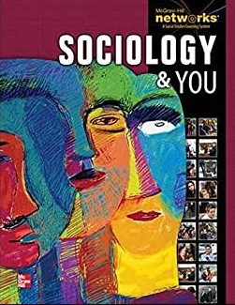 | Sociology and You | McGraw Hill | PISD ConnectEd | Via Webdesk
AAS | 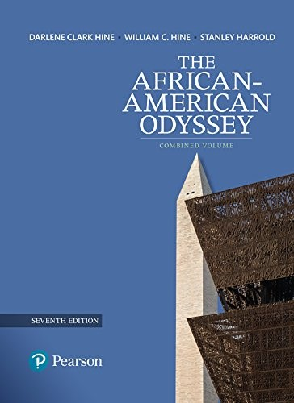 | African American Odyssey | Pearson (Savvas) | N/A | N/A
MAS |  | Mexicanos, a History of  Mexicans in the United States | Indiana University Press | N/A | N/A
MAS | 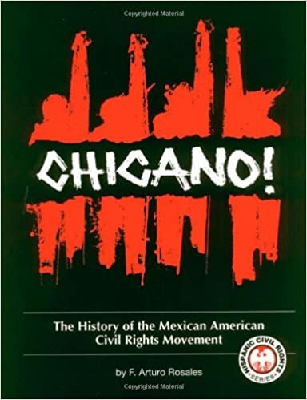 | Chicano!, the History of the Mexican American  Civil Rights Movement | Arte Publico Press | N/A | N/A
MAS | 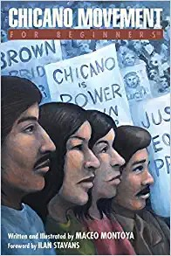 | Chicano Movement for Beginners | For Beginners | N/A | N/A
HGAP | 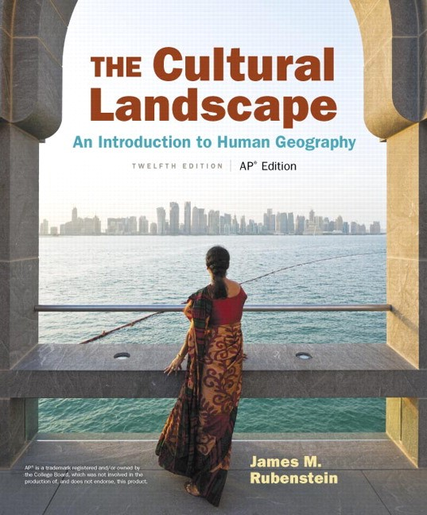 | The Cultural Landscape,  An Introduction to  Human Geography | Pearson (Savvas) | PISD Pearson | Via Webdesk
WHAP  HUM I  HUM II | 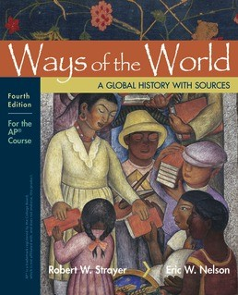 | Ways of the World, a  Global History with Sources | BFW | PISD BFW | Via Webdesk
AP EURO | 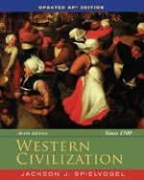 | Western Civilization | Cengage | PISD Cengage | Via Webdesk
APUSH  American Studies |  | Give Me Liberty, an American History | WW Norton | PISD WW Norton | Via Webdesk
AP GOV |  | Government in America | Pearson (Savvas) | PISD Pearson | Via Webdesk
AP  Comparative  Gov | 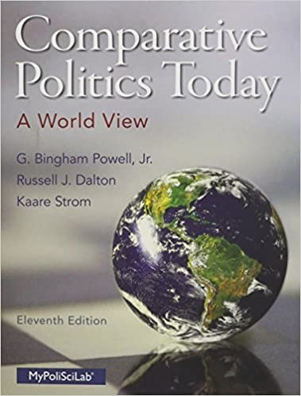 | Comparative Politics Today, a World View | Pearson (Savvas) | PISD Pearson | Via Webdesk
APECON |  | Economics | BFW | PISD BFW | Via Webdesk
APPSY |  | Psychology | BFW | PISD BFW | Via Webdesk

