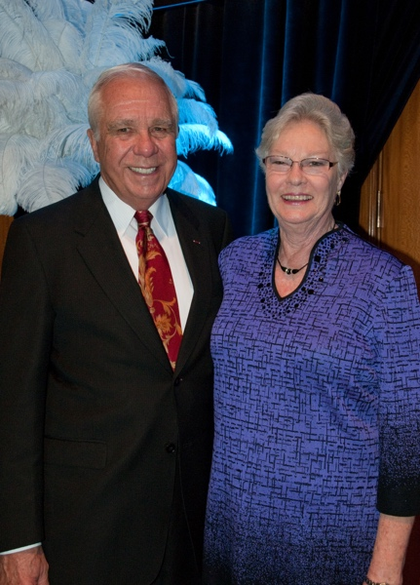 *Dr. Robbie Robinson and his late wife Lynore Robinson (pictured here in 2012) will be the namesakes of the Robbie and Lynore Robinson Fine Arts Center – Plano ISD.*