**PHOTO CAPTION:**

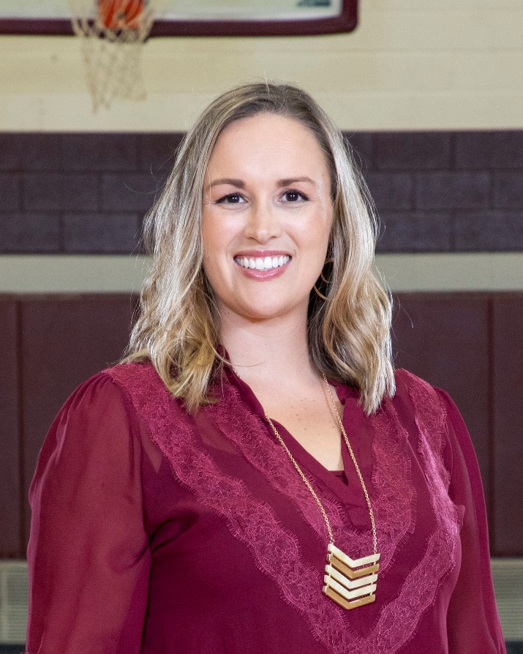

Kelly Stallings.