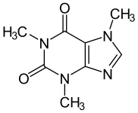Honors Chemistry Syllabus

The Chemistry-Honors course is designed to introduce the student to the qualitative and quantitative aspects of a first year chemistry program. An in-depth study of the mathematical applications will be stressed. The course will emphasize the theoretical concepts of molecular bonding, thermodynamics, kinetics, and equilibrium. The descriptive aspects of the periodic table will be dealt with throughout the course. **Students will complete an independent research project.**

## Safety (9 instructional days)

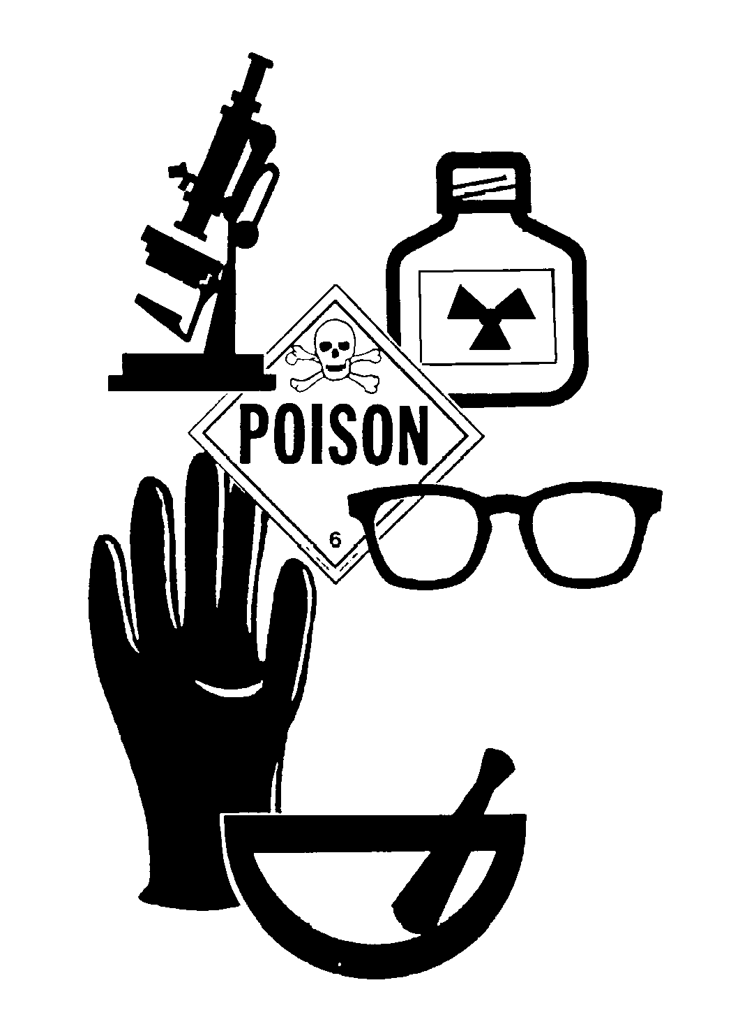

Throughout this 9-day unit, students will explore safety in the lab. Students will demonstrate an understanding of safe lab practices, how to read a SDS, the use and location of safety equipment, and identify lab safety symbols. Students will also plan and implement investigative procedures, including asking questions, formulating testable hypotheses, and selecting equipment and technology.

## Defining Matter (45 instructional days)

 Throughout this 8 week unit, students will study the properties of matter and classify it into elements, compounds, and mixtures. They will learn about various scientists’ theories about atomic structure and study the properties of different subatomic particles. They will understand the difference between atomic mass and average atomic mass. Students will describe the relationships between energy, wavelength, and frequency and learn about the importance of the quantized electron energy and its relationship to atomic spectra. Students will identify the relationship between family (location) vs # of valence electron(s) and the pattern of energy levels as it relates to the periods on the periodic table. They will explore the patterns of the periodic table through various labs and activities. This unit includes the Organized Chaos Performance Assessment where the students will create an organizational chart of everyday items with a written and oral justification.

## Nuclear (5 instructional days)

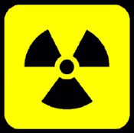 Throughout this week long unit, students will study the characteristics of alpha, beta, and gamma radiation, learn how to write balanced nuclear equations, understand the concept of half-life, and compare and contrast the characteristics, examples, and applications of fission and fusion. Students will explore how nuclear chemistry can be impactful for society (examples may include C-14 dating, energy production, medical applications, military, etc).

## Synthesizing Matter (61 instructional days)

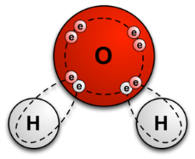During this unit students study how different forms of matter interact chemically. They discover the significant role that electrons play in the formation of ionic, covalent, and metallic bonds. They learn how to name and write formulas for ionic and covalent compounds as well as compare their chemical and physical properties. Students build on their understanding as they learn to write, balance chemical equations, and then classify these reactions as one of 5 reaction types. As the unit progresses, students become proficient in using dimensional analysis and mole relationships including molar mass, and Avogadro’s number to calculate mass, moles, and representative particles. They further develop their understanding of the interactions of matter as they use stoichiometric relationships between elements and compounds to determine limiting and excess reactants, and calculate quantities involved in chemical reactions.

## Behavior of Matter (49 instructional days)

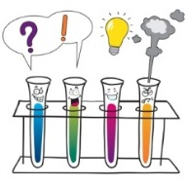 Students will investigate using calorimetry the process of thermal energy transfer, describe and calculate the energy transfer between a system and the surroundings. Students will evaluate the energy change in a chemical reaction using balanced thermochemical equations and graphical analysis and relate those changes to bond forming (exothermic) and bond breaking (endothermic). Students will also investigate patterns of solubility and how solubility is related to molecular structure and polarity of molecules. Students will be able to link solubility to the specific intermolecular forces and investigate physical properties associated with those forces. Students will be able to describe phases of matter, calculate and interpret the energy transfer that occurs when phase changes happen. Students will investigate and calculate gas relationships involving pressure, temperature, volume and moles. Students will use inquiry methods of investigation to determine relationships involving the ideal gas law. Students will investigate and compare the properties of acids and bases, calculate the pH of various solutions, and use titration techniques to evaluate the concentration of an unknown substance. In all sub-units students will evaluate the influence of chemistry in their community and society.