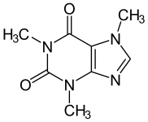Chemistry Syllabus

Chemistry is the study of the structure, composition, and behavior of matter. The course of study emphasizes the investigation of matter, its interactions, and the factors affecting the interactions. Chemistry is a laboratory-oriented course that stresses the observation of matter and its behavior, classification of matter, communication of data, measurement of chemical quantities, prediction of chemical phenomena, and manipulation of chemical investigations.

## Safety & Diagnostic Check (8 instructional days)

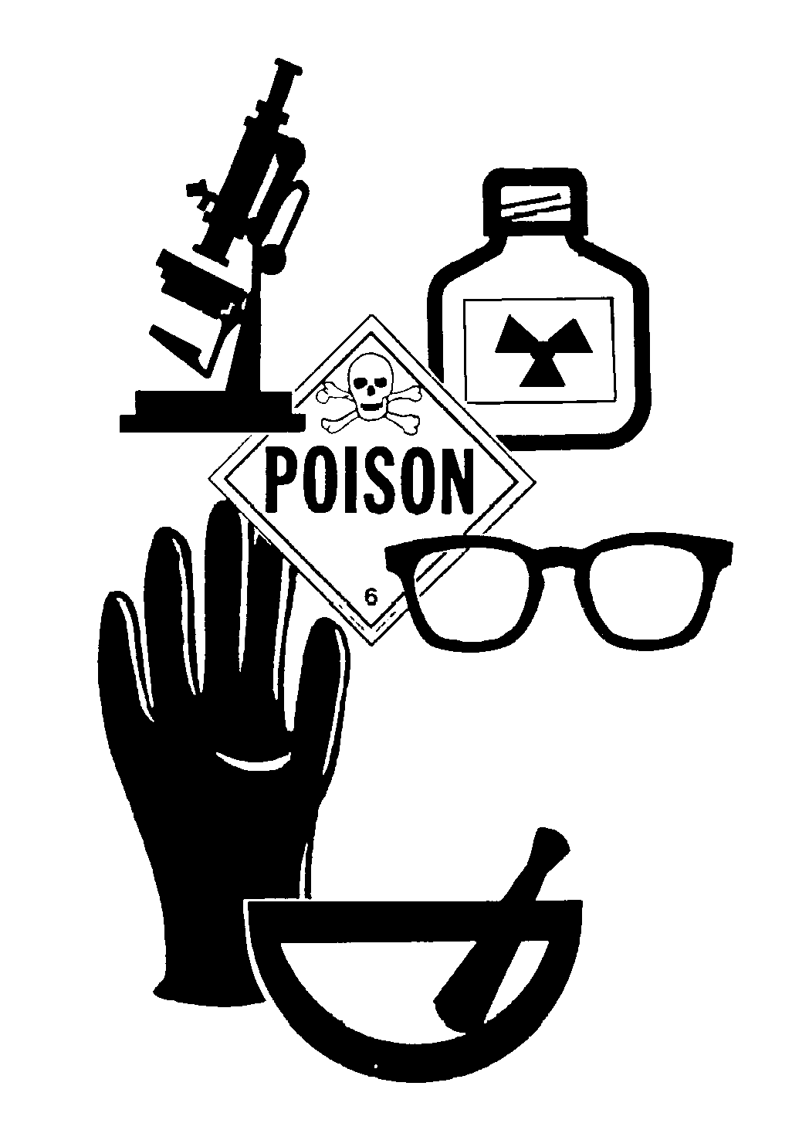

Throughout this 8 day unit, students will explore the safety in the lab. Students will demonstrate an understanding of safe lab practices, how to read a SDS, the use and location of safety equipment, and identify lab safety symbols. Students will plan and implement investigative procedures, including asking questions, formulating testable hypotheses, and selecting equipment and technology. Students will also demonstrate their current knowledge of math skills via diagnostic check.

## Defining Matter (43 instructional days)



Throughout this unit, students will study the how to classify the intensive and extensive properties of matter and identify physical and chemical changes. They will explore the development of modern atomic theory and properties of subatomic particles through various labs and activities. Students will study the periodic table including early contribution by scientists the relationships between the rows, groups and the trends and how to determine the charge of an ion. Students will also be introduced to the concept of the mole and one-step molar conversions.

## Nuclear (3 instructional days)

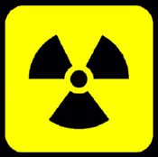

Throughout this brief unit, students will study the characteristics of alpha, beta, and gamma radiation, learn how to write balanced nuclear equations, and compare and contrast the characteristics, examples, and applications of fission and fusion. Students will explore how nuclear chemistry can be impactful for society (examples may include C-14 dating, energy production, medical applications, military, etc).

.

## Synthesizing Matter (Fall = 29 instructional days, Spring = 33 instructional days)

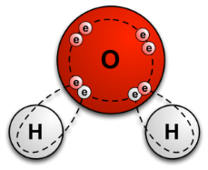

Students will explore the different properties (chemical and physical) of substances and relate it to the arrangement of atoms. Students will balance chemical equations to demonstrate the Law of conservation of mass. In addition, students will construct e-dot diagrams to illustrate the movement of electrons. Students will research the fundamental concept of the mole and use it calculate mass and number of particles. They will also, determine conversion factors involving the mole and use it to determine the limiting reactant in a balanced equation.

## Behavior of Matter (53 instructional days)

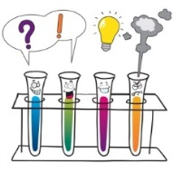

Students will explore the importance of water in terms of polarity, specific heat and universal solvation. Students will also investigate solubility rules and how solubility can be influenced by changing experimental conditions. Students will define and describe energy changes that occur in chemical reactions to bond breaking and bond forming. Students will investigate and calculate the process of thermal energy transfer between a system and the surroundings and will evaluate the energy change in a chemical reaction using balanced thermochemical equations. Students will be able to describe phases of matter and the energy transfer that occurs when phase changes happen. Students will investigate and calculate gas relationships involving pressure, temperature, volume and moles. Students will investigate and compare the properties of acids and bases. In all sub-units students will evaluate the influence of chemistry on their community and society.